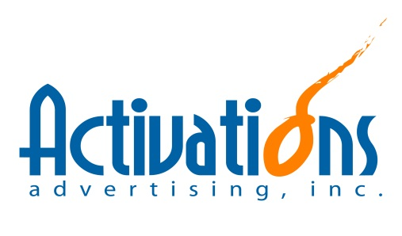
JOB ORDER NO.: UNKC2015-_________ DATE: February 5, 2015
Ambient Tie-ups
Sampling/Selling Activations/Events
Others

CLIENT: Unilever Philippines - Marketing
PRODUCT: Various
PROJECT: ART Workshop
ACCOUNT HANDLER: Kim Chua

EVENT DETAILS:
- What: ART Workshop (Marketing Workshop)
- When: March 05-06, 2015
- Where: TBC
- Expected Attendees: 100 Attendees

EVENT OVERVIEW:
- Authenticity. Relevance. Talkability.
  - Cascade launch in different Unilever countries
  - Same foundation as with CB4L
    - Key elements in CB4L: Communication and Innovation
- Marketing cascade that will be led by Marketing’s big bosses – Gina and Benjie
  - Program Flow – C/o Unilever
  - Modules – C/o Unilever

SET-UP OVERVIEW:
- Typical workshop with tables (but comfy/cozy type of ambiance)
- Audio-Visual set-up
- Lights and Sounds set-up
- Make use of premium-looking structures (ex. Wooden easels, etc.)
- No tarps (Should be premium-looking)

OTHER REQUIREMENTS:
- Photo and video documentation

REQUIREMENTS:
DEPARTMENT | DELIVERABLES |  | DEADLINE | NEXT STEPS
CREATIVES |  | To Follow
OPERATIONS SUPPORT |  | 1. Check possible venues for the 2-day workshop  - 71 Gramercy  - Hive  - Raven  - Aracama  - Marco Polo (Bar)  - Universe  - Fullybooked (The Fort)  Venue considerations:  - Area: Should be Makati / Fort  - Venue Capacity  - Venue Set-up (Tables/Chairs)  - Food  - Parking  - In-house Equipment (Audio-Visual, Others) | Feb. 10
ACTIVATIONS |  | To Follow
PRODUCTION |  | To Follow
SET-UP/LOGISTICS |  | To Follow
PURCHASE/INVENTORY |  | To Follow
HR |  | To Follow
ACCOUNTING |  | To Follow

ATTACHMENTS:
Working Cost Estimate
Working Deck
Working Checklist

RECEIVED:
_________________________________
Operations Division

